BP 2410 Board Policies and Administrative Procedures –  Chapter Lead Response (10+1)  P&P Chapter Lead Recommendation  San Bernardino Community College District | 02/15/24  Current Step:  Level 3 to Constituents for Feedback & First Anticipated AS Review

Point Person | Date Requested | Anticipated Date of Recommendation: | Recommendation Received:
J Torres | 11/1/2023 | Recommendation Received | 12/5/2023
Reason(s) for Review/Changes
> Legal Update 40: The Service updated this policy to clarify that in unusual circumstances the governing board may adopt changes at the same meeting at which they are introduced. (2022-23 carryover)

Review Level
Level 3

Anticipated AP2410 Schedule (for info on this process, visit https://sbccd.edu/ap2410)
09/06/2023 BPPAC Approval
09/18/2023 PPAC Approves Review Level
09/20/2023 Level 3 First Anticipated AS Review
10/09/2023 Level 3 PPAC Reviews Constituent & Initial AS Feedback
10/18/2023 Level 3 Second Anticipated AS Review
11/13/2023 PPAC Reviews Second AS Feedback
12/05/2023 BPPAC Approval of Chapter Lead Response to AS Input
12/11/2023 PPAC Reviews Feedback to AS Input
12/05/2023 BPPAC Approval
12/11/2023 PPAC Approves Review Level
02/07/2024 Level 3 First Anticipated AS Review
02/26/2024 Level 3 PPAC Reviews Constituent & Initial AS Feedback
03/06/2024 Level 3 Second Anticipated AS Review
03/11/2024 PPAC Reviews Second AS Feedback
04/11/2024 BOT First Reading
05/09/2024 BOT Final Approval

Action Requested

1. Please review this Chapter Lead recommendation based on the reasons above.
2. Staff recommended changes are shown in red.
3. Legal changes are shown in blue and should only be considered optional if indicated.
4. If there are no changes showing, this item is being presented for information only.
5. For questions on this recommendation, please contact J Torres or kgoodric@sbccd.edu.

RECOMMENDATION STARTS ON NEXT PAGE

BP 2410 Board Policies and Administrative Procedures  Chapter Lead Response (10+1)  P&P Chapter Lead Recommendation  San Bernardino Community College District |  | 02/15/24
Reason(s) for Review/Changes
> Legal Update 40: The Service updated this policy to clarify that in unusual circumstances the governing board may adopt changes at the same meeting at which they are introduced. (2022-23 carryover)
Review Process Notes:

- SBVC 2nd Academic Senate Feedback | There was a vote of No Support for the changes with the following feedback. The update is identified as being due to Legal Update 40 and the faculty were unable to locate the legal advisement or wording that supports the changes. They were asking if this is coming from Ed Code, from CCL, or some other location. Given the legal update, does it require the addition of the words “normally” and “in unusual circumstances” or is this language optional? If there is required language, is there other wording that would indicate more specifically circumstances that qualify as emergent or unusual, or a way to incorporate notification to the constituent groups of an upcoming change. The overall concern of the body is that the words “normally” and “in unusual circumstances” provide an avenue for many things to fall into that category and procedures being changed without following the normal processes outlined in the policy. If the language is not required, our Senate asked to strike it. Either way, they voted No Support as it stands.

- Chapter Owner Feedback below.

The Board may adopt such policies as are authorized by law or determined by the Board to be necessary for the efficient operation of the District. Board policies are intended to be statements of intent by the Board on a specific issue within its subject matter jurisdiction.

The policies have been written to be consistent with provisions of law, but do not encompass all laws relating to District activities. All District employees are expected to know of and observe all provisions of law pertinent to their job responsibilities.

Policies of the Board may be adopted, revised, added to or amended at any regular Board meeting by a majority vote per the AP 2410 approved process. Proposed changes or additions shall normally be introduced not less than one regular meeting prior to the meeting at which action is recommended. In unusual urgent circumstances, the Board may change, amend, or add to Board Policies at the same meeting at which they are introduced. However, such exceptions to the first read/final approval two-month process will not circumvent or replace the AP 2410 Level Review process. In urgent circumstances, Policies of the Board may be adopted at the same Board meeting at which they are introduced. However, such exceptions to the first read/final approval two-month process will not circumvent or replace the AP 2410 Level Review process.

The Board shall regularly assess its policies for effectiveness in fulfilling the District’s mission.

Administrative procedures are to be issued by the Chancellor as statements of method to be used in implementing Board Policy. Such administrative procedures shall be consistent with the intent of Board Policy. Administrative procedures may be revised as deemed necessary by the Chancellor through regular consultation processes and/or as required by revisions to laws and regulations. Administrative procedures are forwarded to the Board of Trustees. The Board reserves the right to direct revisions of the administrative procedures should they, in the Board’s judgment, be inconsistent with the Board’s own policies.

Board policies and administrative procedures are to be reviewed as per the schedule specified in AP 2410. Board policies and administrative procedures shall be readily available on the District’s website.

Reference:
Education Code Section 70902;
ACCJC Accreditation Standards IV.C.7, IV.D.4, I.B.7, and I.C.5 (formerly IV.B.1.b & e)
End of Recommendation for BP 2410 Board Policies and Administrative Procedures - Chapter Lead Response

AP 2410 Board Policies and Administrative Procedures –  Chapter Lead Response (10+1)  P&P Chapter Lead Recommendation  San Bernardino Community College District | 02/15/24  Current Step:  Level 3 First Anticipated AS Review

Point Person | Date Requested | Anticipated Date of Recommendation: | Recommendation Received:
J Torres | 11/1/2023 | Recommendation Received | 12/5/2023
Reason(s) for Review/Changes
> No Change; FYI Only

Review Level
Level 3

Anticipated AP2410 Schedule (for info on this process, visit https://sbccd.edu/ap2410)
> No Change; FYI Only

Action Requested

1. Please review this Chapter Lead recommendation based on the reasons above.
2. Staff recommended changes are shown in red.
3. Legal changes are shown in blue and should only be considered optional if indicated.
4. If there are no changes showing, this item is being presented for information only.
5. For questions on this recommendation, please contact J Torres or kgoodric@sbccd.edu.

RECOMMENDATION STARTS ON NEXT PAGE

AP 2410 Board Policies and Administrative Procedures –  Chapter Lead Response (10+1)  P&P Chapter Lead Recommendation  San Bernardino Community College District |  | 02/15/24
Reason(s) for Review/Changes
> No Change; FYI Only
Review Process Notes:

The Policies and Procedures Advisory Committee (PPAC) to the Chancellor’s Council is charged with updating, creating, developing, and systematically reviewing Board Policies (BP)/ Administrative Procedures (AP), also known as Policies and Procedures (P&P). This task is accomplished through a cyclical schedule which begins each academic year. The process is intended to:
- Efficiently allow for regular evaluation of policies and procedures.
- Provide faculty, staff, and students an opportunity to express opinions, and give those opinions every reasonable consideration.
- Ensure the right of academic senates to assume primary responsibility for making recommendations in the areas of curriculum and academic standards.
I. STARTING POINT
- Policies & Procedures are incorporated into the Review Schedule in one of three ways: Annual Review, Legal Updates, or Other Requests.
- Policies & Procedures are reviewed in pairs, when applicable, to ensure the AP supports the direction outlined in the BP.
- BPs require Board approval. APs are submitted to the Board for informational purposes; however, the Board may direct revisions of any APs judged to be inconsistent with BPs.
- The Chancellor’s designee facilitates this process.
A. Annual Review
The Board will receive a list annually and prioritize the policies that need to be reviewed. Prior to the start of each academic year, the Chancellor's designee will take the necessary steps to initiate review of 10% of SBCCD’s P&Ps, including:
- Identify appropriate P&Ps for review.
- Work with Academic Senate Presidents to determine which P&Ps fall under 10+1.
- Notify Chapter Leads responsible for review.
- Develop a timeline.
- Present a Review Schedule to PPAC in September.
- Maintain and publish the Review Schedule on PPAC webpage throughout the year.
B. Legal Updates
SBCCD keeps current with changes in law or accreditation standards through a subscription to the Community College League of California. This service issues periodic legal updates which promote regulatory compliance and familiarity with industry best practices. Legal updates do not need Board review prior to going through the process.
Upon receipt of a Legal Update, the Chancellor's designee will take the necessary steps to initiate review of affected P&Ps, including:
- Add P&Ps to the Review Schedule.
- Work with Academic Senate Presidents to determine which P&Ps fall under 10+1.
- Notify Chapter Leads responsible for review.
C. Other Requests
Other requests for P&P review may be Chapter Lead-initiated, or come from a trustee, a staff member, or a student. All such requests should be submitted to the Chancellor’s designee who will take the necessary steps to initiate review, including:
- Add P&Ps to the Review Schedule.
- Work with Academic Senate Presidents to determine which P&Ps fall under 10+1.
- Notify Chapter Leads responsible for review.
II. CHAPTER LEAD REVIEW & RECOMMENDATION
Chapter Leads are the responsible “owners” of SBCCD P&Ps. These individuals are charged with reviewing and making recommendations based on general correctness and operational feasibility, including alignment with current practices, legal considerations, mandates, etc. SBCCD Chapter Leads are listed in the Definitions section of AP 2410.
- Chapter Leads receive requests to review P&Ps, and/or suggestions to revise P&Ps, from the Chancellor’s designee.
- Chapter Leads are encouraged to collaborate with appropriate constituent groups before making a recommendation to PPAC. ALL P&Ps designated 10+1 will use Academic Senate as the primary recommending body.
- Chapter Leads return a recommendation to the Chancellor’s designee based on the outcome of the review (i.e., reviewed with no change, reviewed with minor revisions, reviewed with content change, suggested deletion, etc.)
- The Chancellor’s designee assigns the recommendation a rating of Level 1 | Info Only, Level 2 | Minor Review (Non 10+1), or Level 3 | Extensive Review and includes item on the PPAC agenda.
III. CONSTITUENT FEEDBACK TO FINAL APPROVAL
Constituent feedback is collected through the appointed PPAC representatives and reviewed at committee meetings. The Review Schedule is posted on the PPAC webpage, and a report of PPAC activity is sent districtwide to keep all SBCCD employees informed.
To promote efficiency and respect the time of PPAC and constituent group members, P&Ps are categorized by level of review. This is to streamline the process and promote efficiency. PPAC members will assess review levels to ensure appropriateness.
A. Level 1 | Info Only
- These appear on the PPAC agenda for confirmation of review level assignment and are generally comprised of items that are:
  - Reviewed with no changes.
  - Reviewed with only minor clerical edits or legal reference changes.
  - Chapter 2 Board of Trustees P&Ps that do not fall under 10+1.
- All items deemed appropriately placed in Level 1 by PPAC members are:
- Simultaneously forwarded to constituent groups for information only, forwarded to Chancellor’s Council, and scheduled for BOT first read.
- The month following BOT first read, items should appear on the BOT agenda for second read and final approval.
- Items that do not receive BOT approval should begin the cycle again under the Other Requests method.
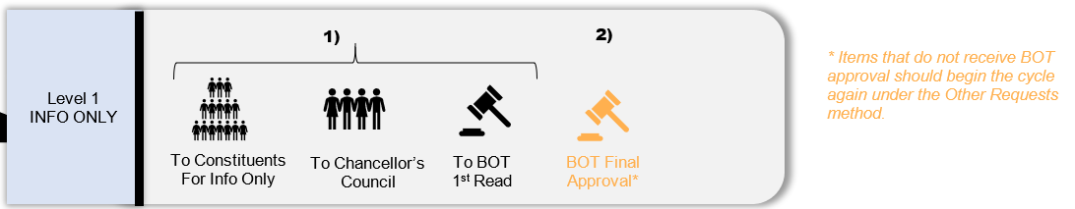
B. Level 2 | Minor Review (Non 10+1)
- These appear on the PPAC agenda for confirmation of review level assignment and are generally comprised of recommendations involving:
  - Existing P&Ps which are simple and non-controversial.
  - New P&Ps that are simple and non-controversial.
- All items deemed appropriately placed in Level 2 | Minor Review (Non 10+1) by PPAC members begin the following review process.
- PPAC representatives solicit constituent feedback which is uploaded via Microsoft Teams.
- Constituent feedback is forwarded to Chapter Leads to be reviewed for operational applicability and feasibility, and a determination on any suggested edits is made.
- At its next meeting, PPAC members review constituent feedback and the corresponding Chapter Lead determination, responding to the determination with No Changes or Minor Edits. (Substantial Edits are not expected for Level 2 | Minor Review recommendations.)
  - No Changes: Items with no changes are forwarded to Chancellor’s Council and scheduled for BOT first read.
  - Minor Edits: When appropriate, minor edits are incorporated into P&Ps, and Chapter Leads made aware. These items are then forwarded to Chancellor’s Council and scheduled for BOT first read.
  - Substantial Edits: Substantial edits are not expected for Level 2 | Minor Review recommendations. Any substantial edits will cause these items to be moved to Level 3 | Extensive Review.
- The month following BOT first read, items should appear on the BOT agenda for second read and final approval.
- Items that do not receive BOT approval should begin the cycle again under the Other Requests method.
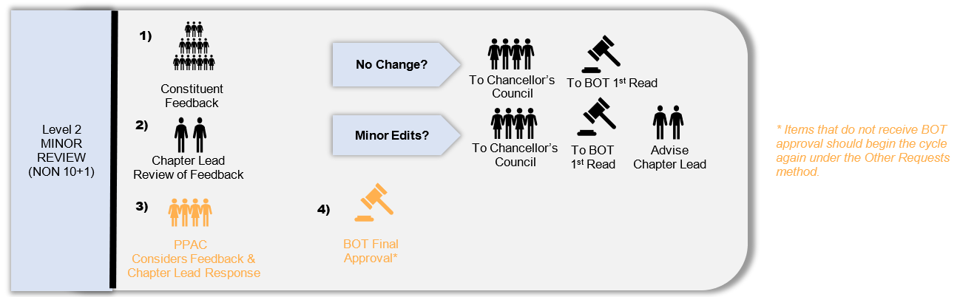
C. Level 3 | Extensive Review
- These appear on the PPAC agenda for confirmation of review level assignment and are generally comprised of recommendations involving:
  - Existing P&Ps with substantial changes and/or subject to 10+1
  - New P&Ps that are controversial, complex and/or subject to 10+1
- If consensus cannot be achieved on P&Ps falling under 10+1, Chancellor’s Council will be informed, and the issue referred to Chancellor’s Cabinet to make a determination.
- All items deemed appropriately placed in Level 3 | Extensive Review by PPAC members begin the following review process. Constituent review, especially for the Academic Senate, may take up to two sessions or four weeks. Constituent representatives should keep PPAC members updated as to the work of their constituent groups on these items.
- PPAC representatives solicit constituent feedback which is uploaded via Microsoft Teams.
- Constituent feedback is forwarded to Chapter Leads to be reviewed for operational applicability and feasibility, and a determination on any suggested edits is made.
- At its next meeting, PPAC members review constituent feedback and the corresponding Chapter Lead determination, responding to the determination with No Changes, Minor Edits, or Substantial Edits.
  - No Changes: Items with no changes are forwarded to Chancellor’s Council and scheduled for BOT first read.
  - Minor Edits: When appropriate, minor edits are incorporated into P&Ps, and Chapter Leads made aware. These items are then forwarded to Chancellor’s Council and scheduled for BOT first read.
  - Substantial Edits: Any substantial edits will be forwarded to the Chapter Leads to be reviewed for operational applicability and feasibility.
    - Chapter Lead Acceptance of Edits results in P&Ps being forwarded to Chancellor’s Council and scheduled for BOT first read.
    - For Edits Requiring Further Discussion, Chapter Leads are invited to attend PPAC meeting to discuss, resulting in acceptance or failure to reach consensus.
    - When Consensus Cannot be Reached on Edits, Chancellor’s Council will be informed, and P&Ps referred to Chancellor’s Cabinet for a determination, which will then be scheduled for BOT first read.
- The month following BOT first read, items should appear on the BOT agenda for second read and final approval.
- Items that do not receive BOT approval should begin the cycle again under the Other Requests method.
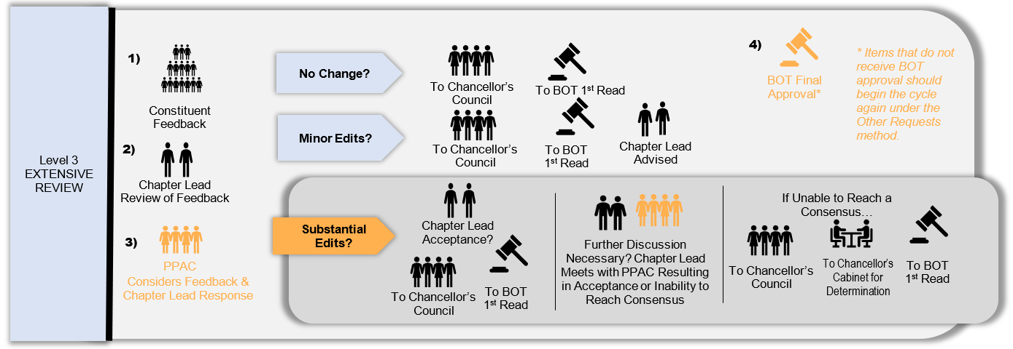
DEFINITIONS
10+1 or Academic and Professional: Relating to policy development and implementation matters for the following:
- Curriculum, including establishing prerequisites and placing courses within disciplines;
- Degree and certificate requirements;
- Grading policies;
- Educational program development;
- Standards or policies regarding student preparation and success;
- District and college governance structures, as related to faculty roles;
- Faculty roles and involvement in accreditation processes, including self-study and annual reports;
- Policies for faculty professional development activities;
- Processes for program review;
- Processes for institutional planning and budget development; and
- Other academic and professional matters as are mutually agreed upon between the governing board and the academic senate.
AP: Administrative Procedure(s)
BOT: Board of Trustees
BP: Board Policy(ies)
Chapters and Chapter Leads: Chapter Leads are the responsible “owners” of SBCCD P&Ps. These individuals are charged with reviewing and making recommendations based on general correctness and operational feasibility, including alignment with current practices, legal considerations, mandates, etc. SBCCD Chapter Leads are listed below.
- Chapter 1: The District | BOT, Chancellor (Lead)
- Chapter 2: Board of Trustees | BOT, Chancellor (Lead)
- Chapter 3: General Institution | Chancellor (Lead) and Chancellor’s Cabinet
- Chapter 4: Academic Affairs | Chancellor’s Designee(s) and Academic Senate Presidents (Co-Leads)
- Chapter 5: Student Services | Chancellor’s Designee(s) and Academic Senate Presidents (Co-Leads)
- Chapter 6: Business & Fiscal Services | Executive Vice Chancellor (Lead) and Vice Presidents of Administrative Services
- Chapter 7: Human Resources | Vice Chancellor of Human Resources and Police Services (Lead)
P&P: Board Procedure(s) and Administrative Policy(ies)
PPAC: Policies and Procedures Advisory Committee, an advisory body to the Chancellor’s Council, charged with updating, creating, developing, and systematically reviewing BPs/APs.
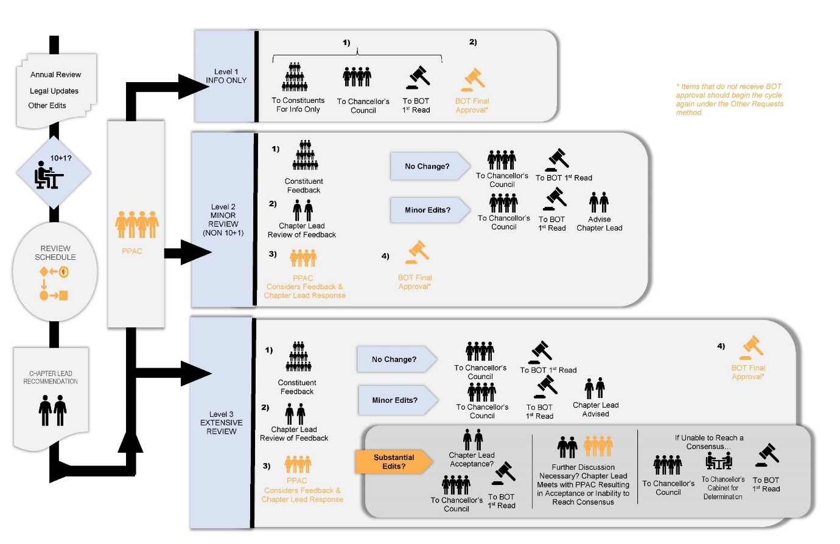
References:
Education Code Section 70902;
ACCJC Accreditation Standards I.B.7; I.C.5; IV.C.7; and IV.D.4 (formerly IV.B.1.b & e)

End of Recommendation for AP 2410 Board Policies and Administrative Procedures - Chapter Lead Response

